1 -OAuth Roles

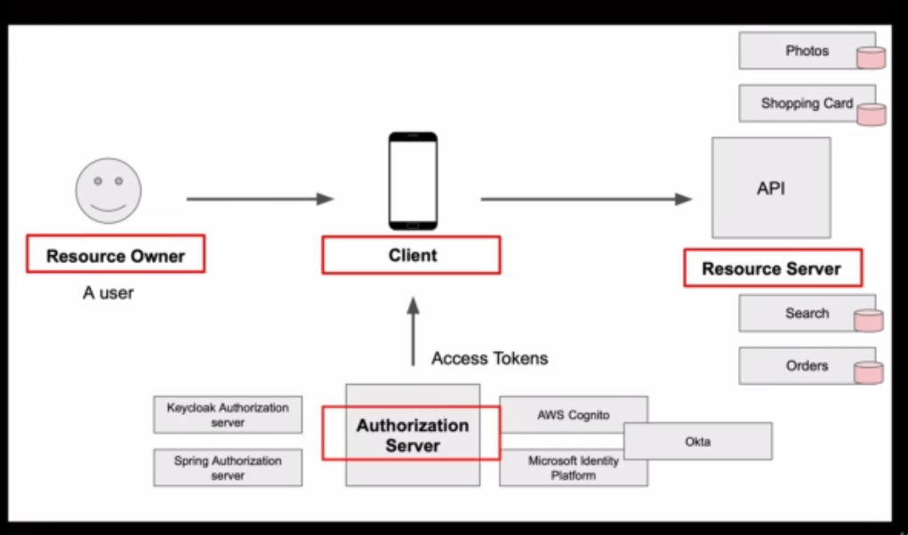

2 – Spring Security 5 – with OAuth 2

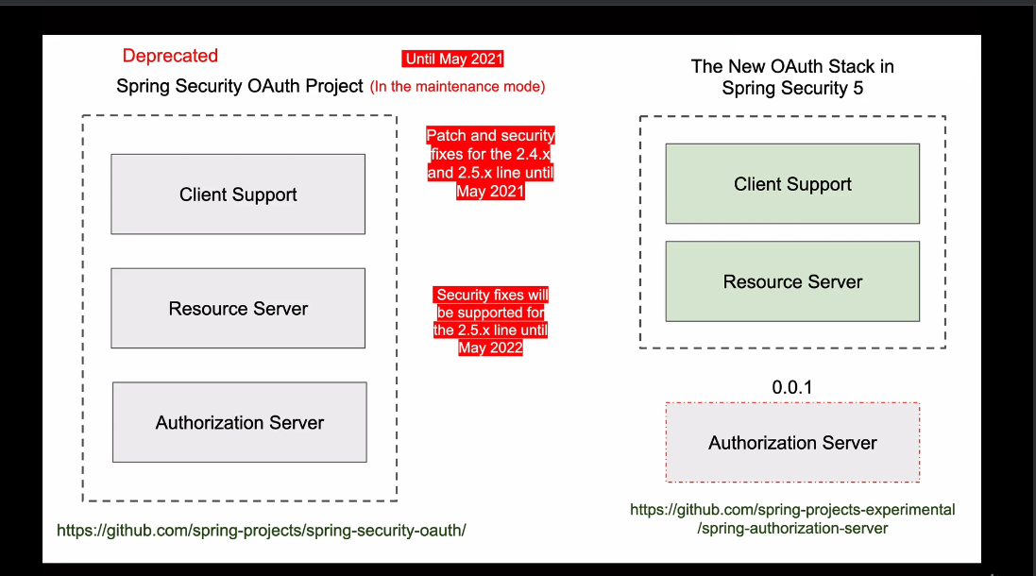

**Access token types**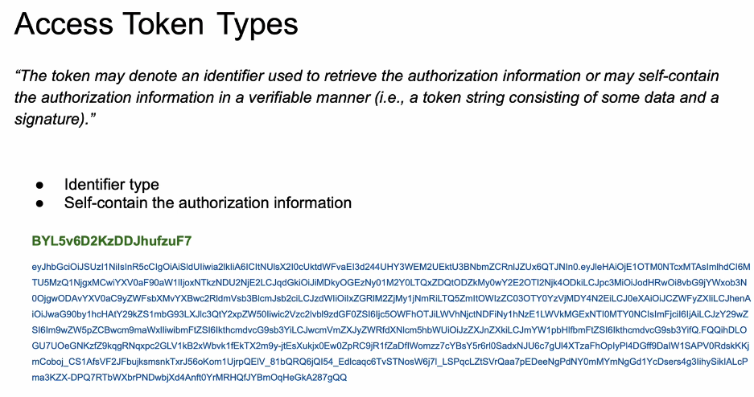

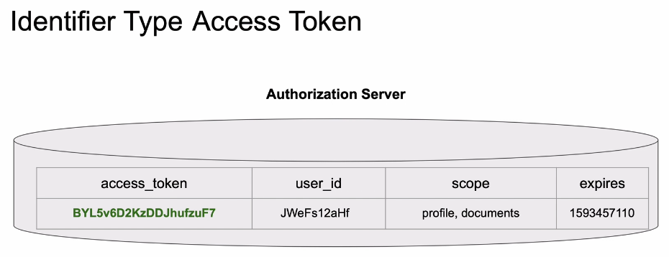

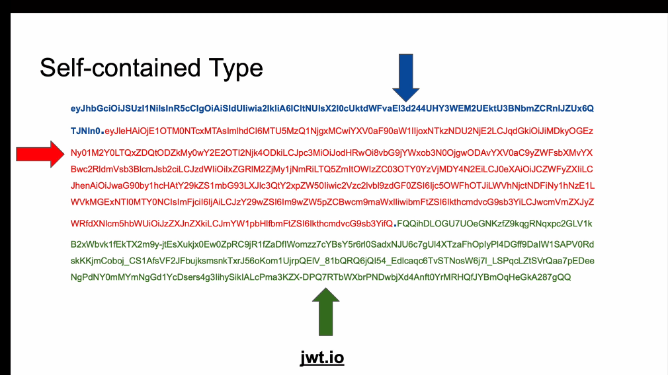

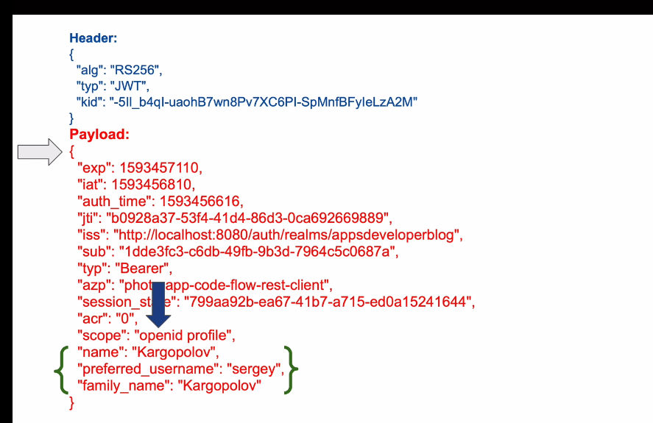

**OAuth 2 & Open ID Connect**

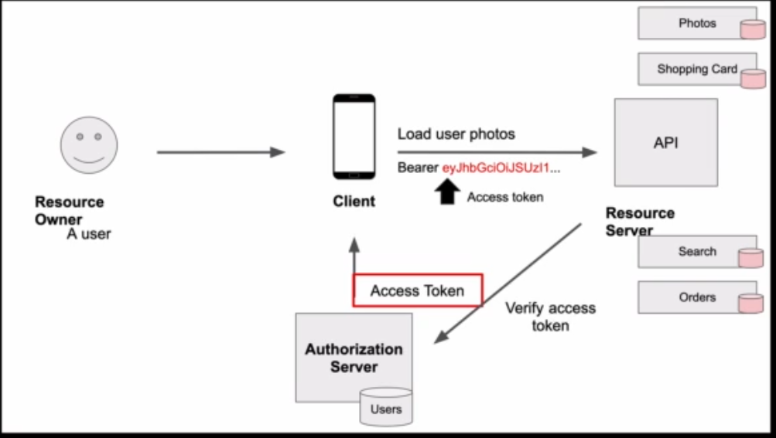

Open ID connect provides additional layer to provide Identity information (as ID Provider with ID token)

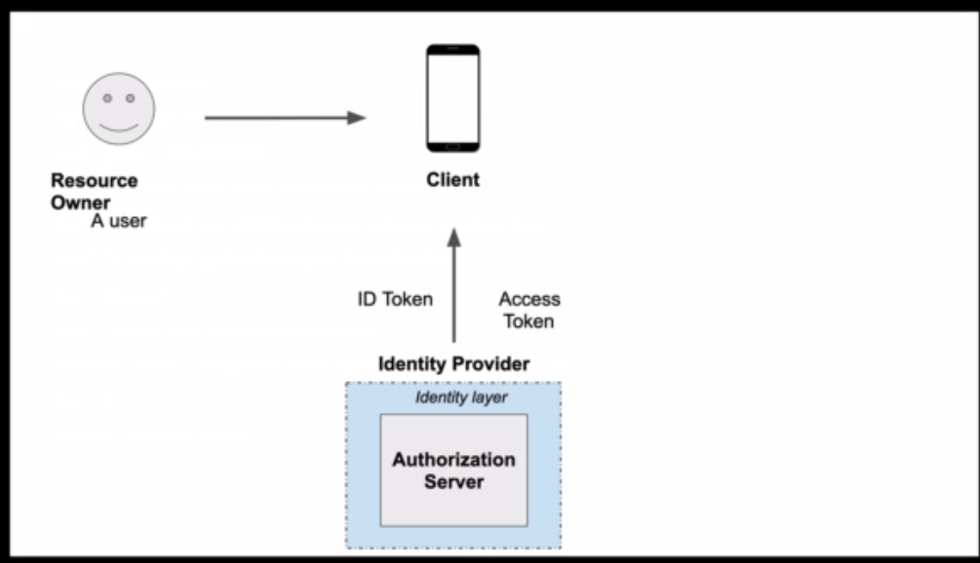

Access token

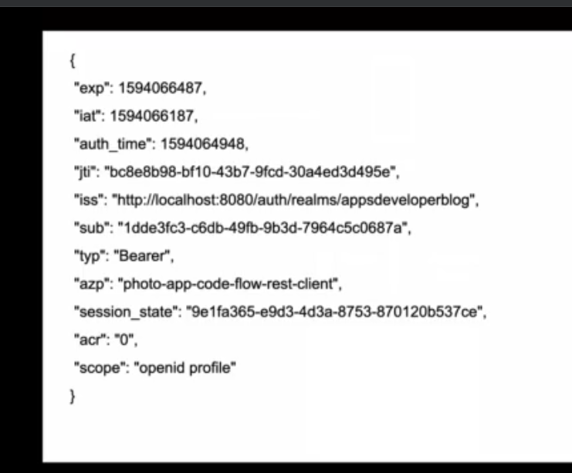

ID Token

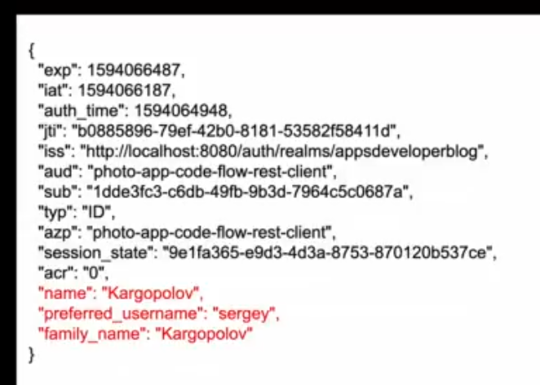

Claims asked (scope)

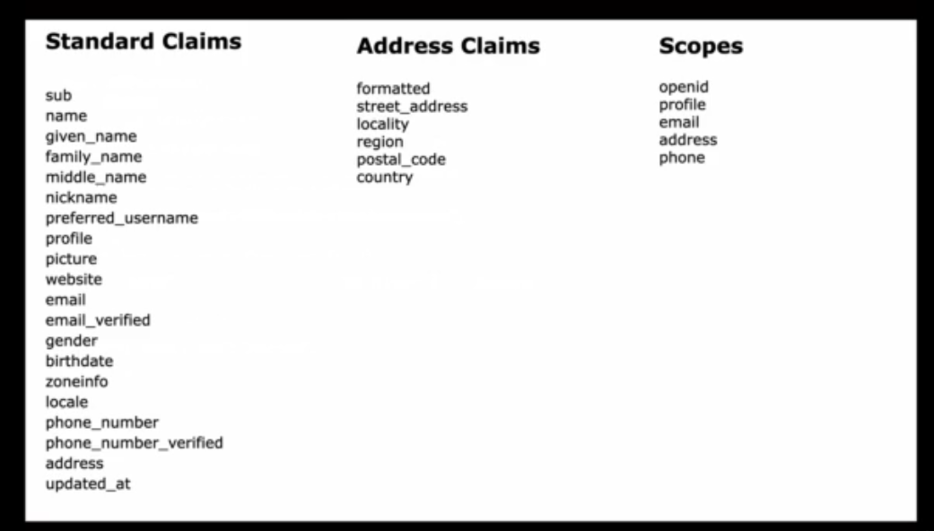

1 – Client type

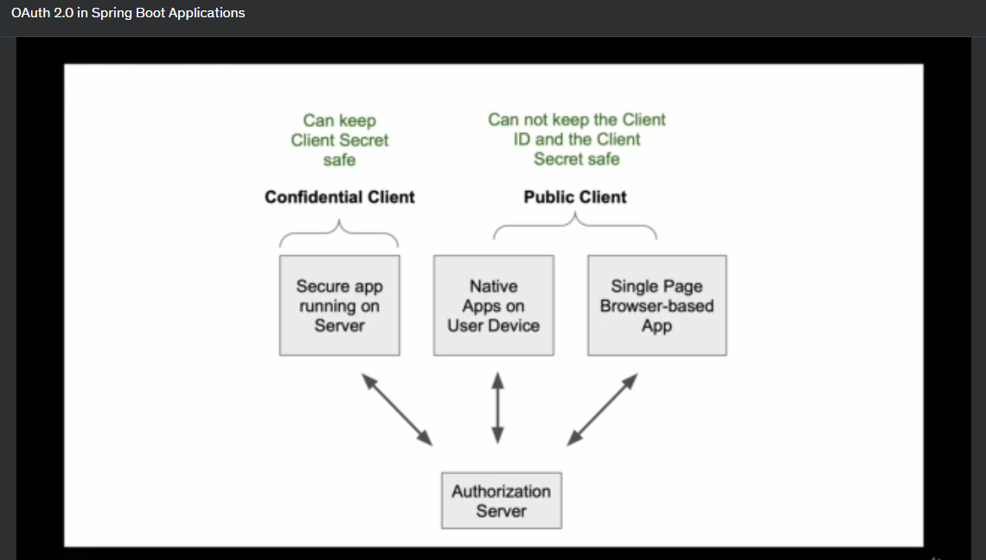

1 – Grant type

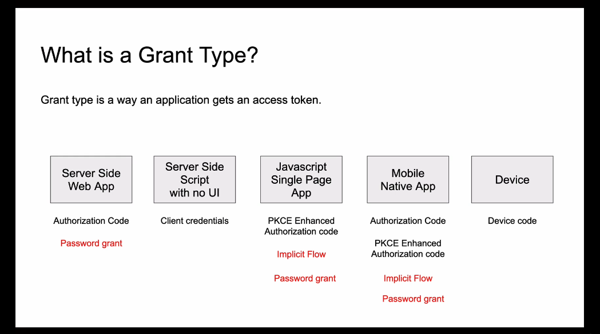

**Grant = Authorization Type**

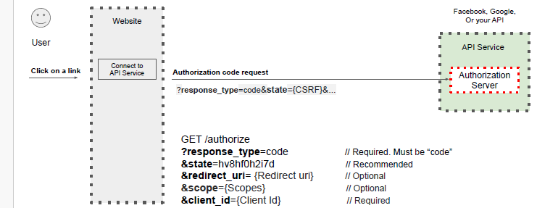

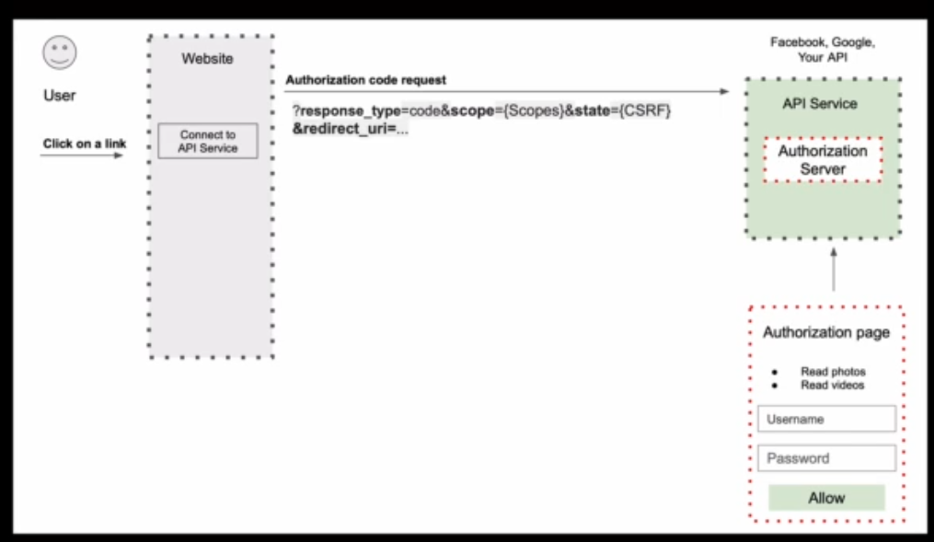

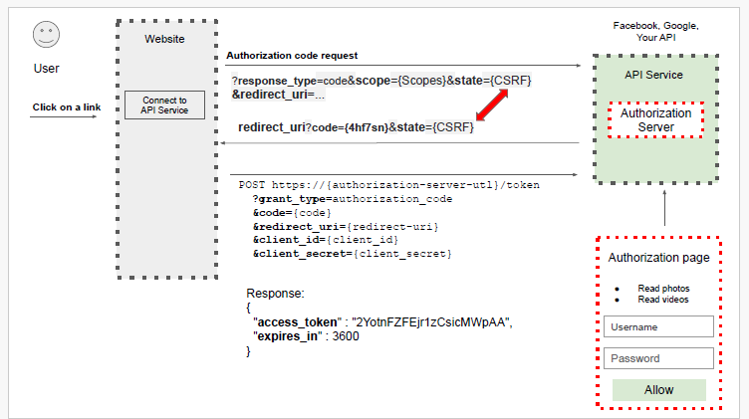

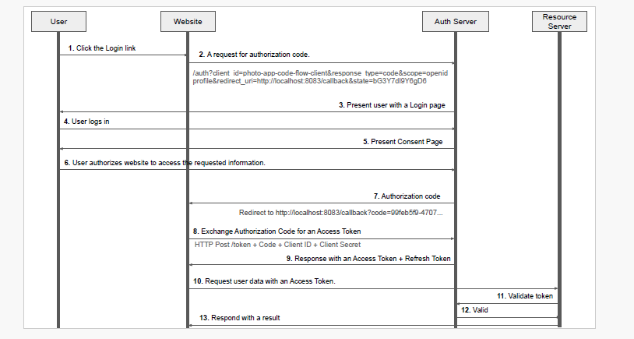

2 - Get Auth code from postman GET call, **response_code=code**, client_id,scope, state, redirect_url

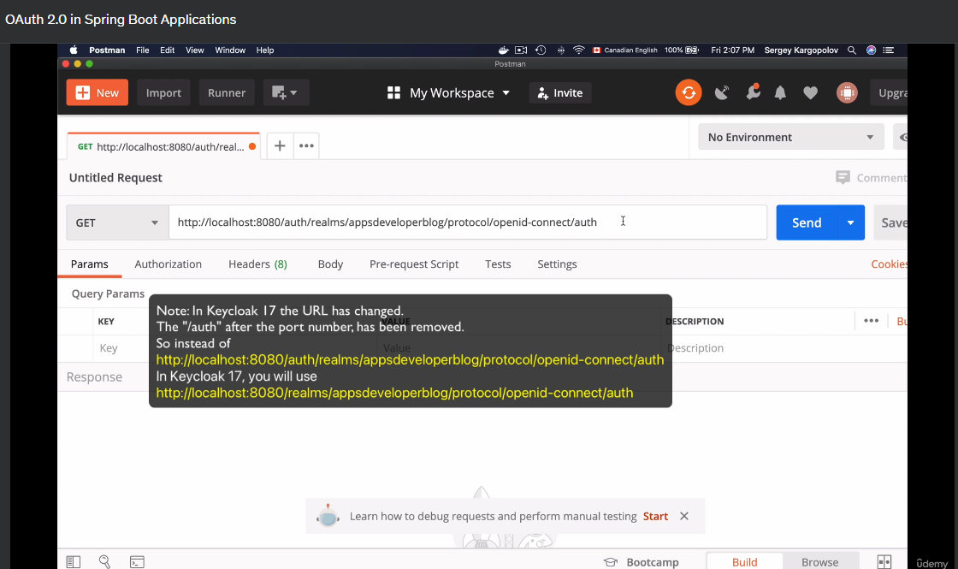

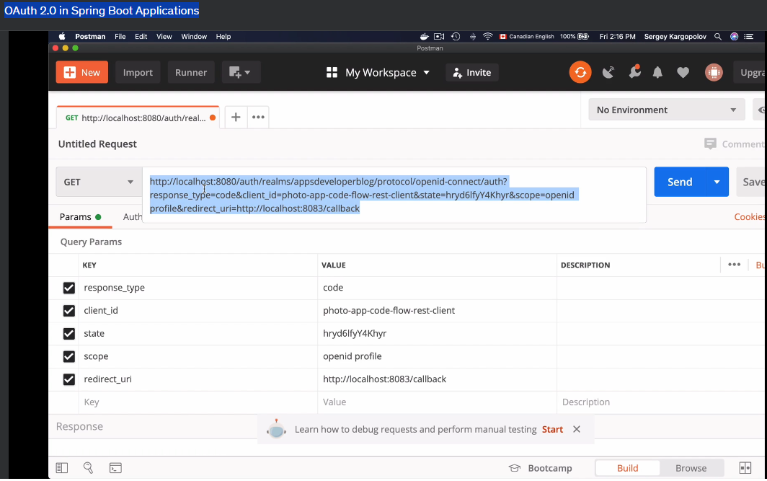

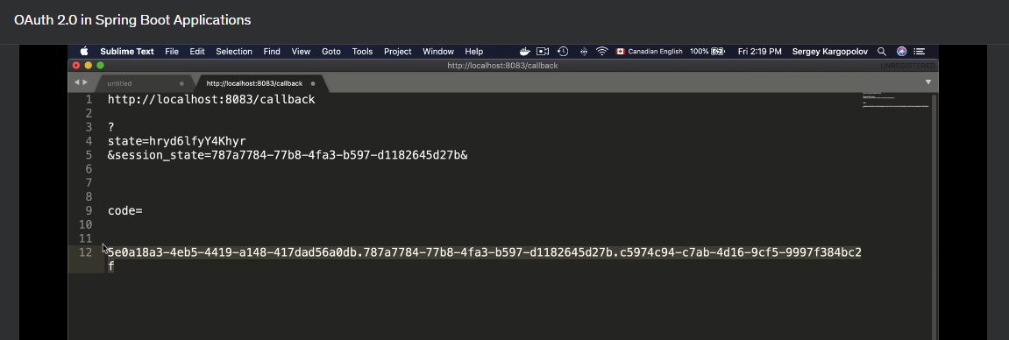

3 Get access-token/refresh token by using the code received from above call (POST Call)

***Grant_type=authorization_code, code,client_id, client_secret, , redirect_uri***

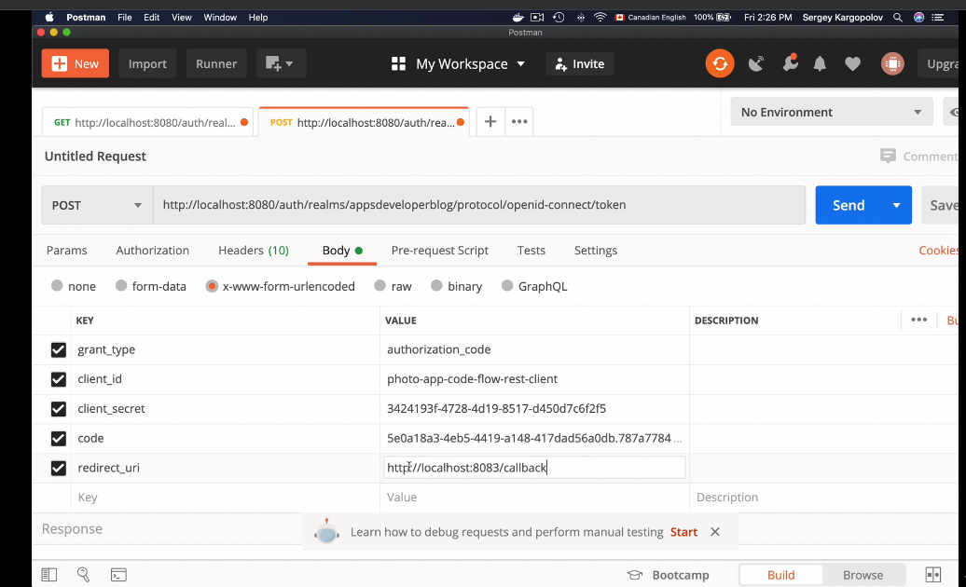

Response with access_token, id_token, refresh_token

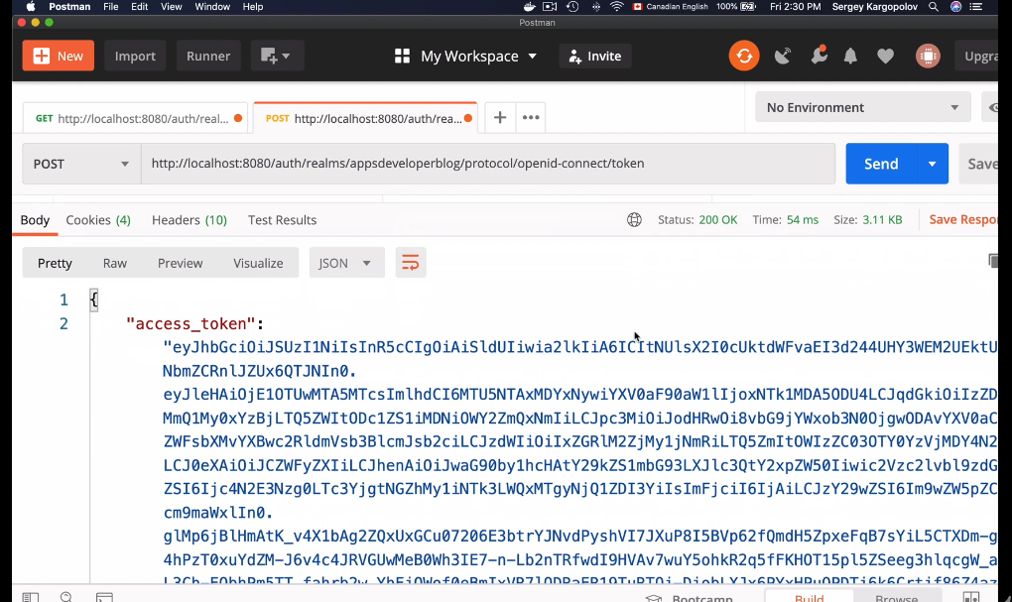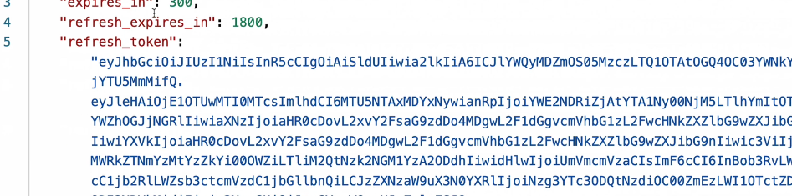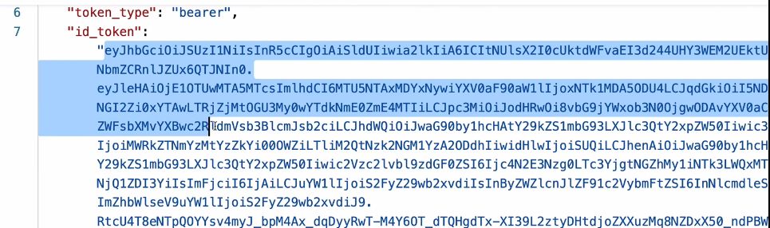

**PKCE – enhanced Authorization Code (Proof Key for Code Exchange)**

1 - Util to generate code verifier, code challenger

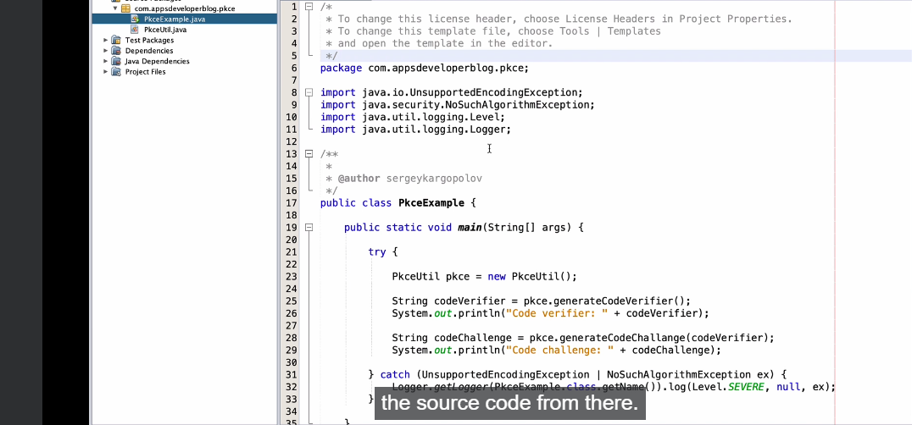

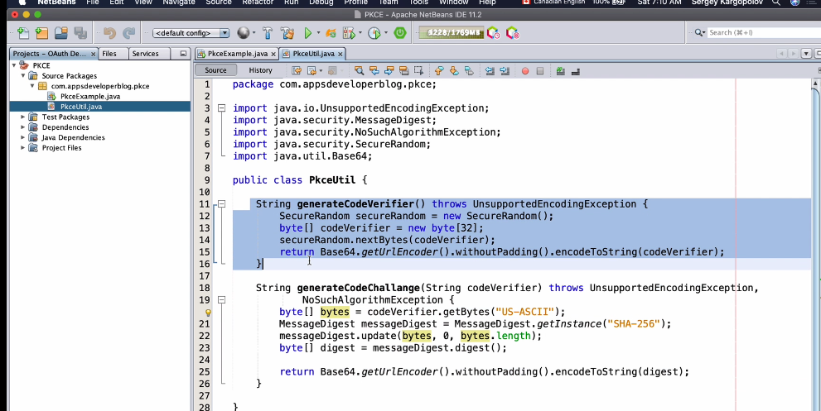

2 – HTTP GET - Get Auth code first, pass ***client_id, response_type, state, scope (openid), redirect_uri, code_challenge_method, code_challenge***

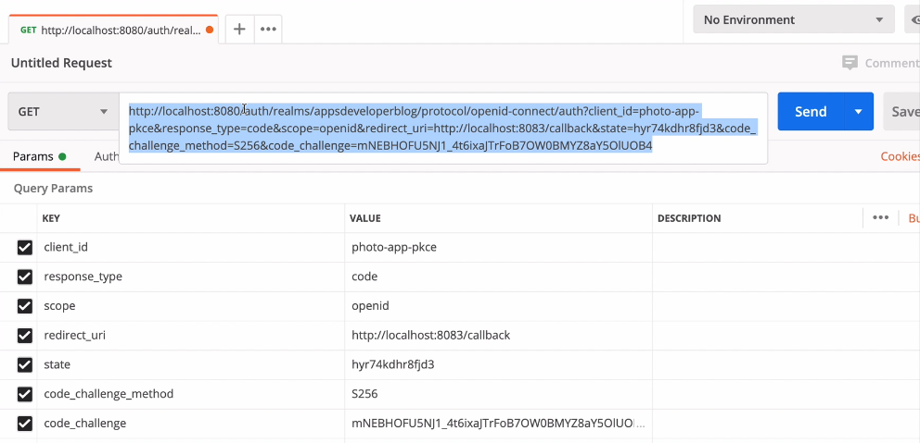

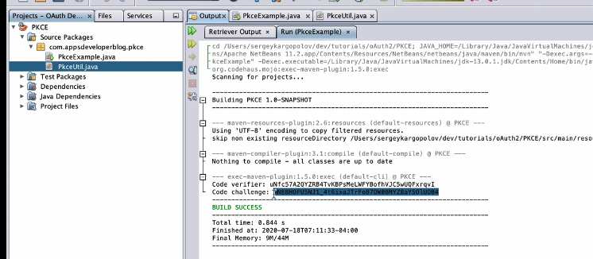

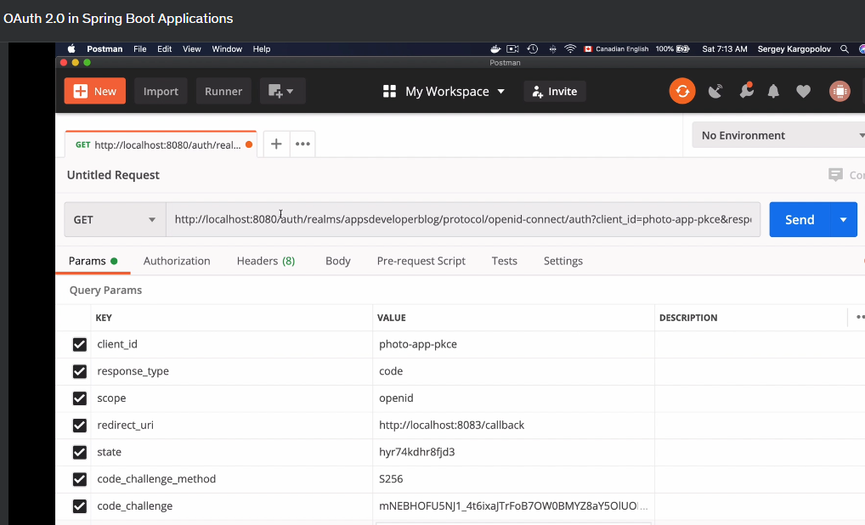

Response with auth code in call back uri



PKCE POST request to access token ***grant_type=authorization_code, client_id, client_secret, code (received previously in GET call for Auth code), redirect_url, code_verifier*** (used previously in GET call for Auth code) – get access token, refresh token & id token

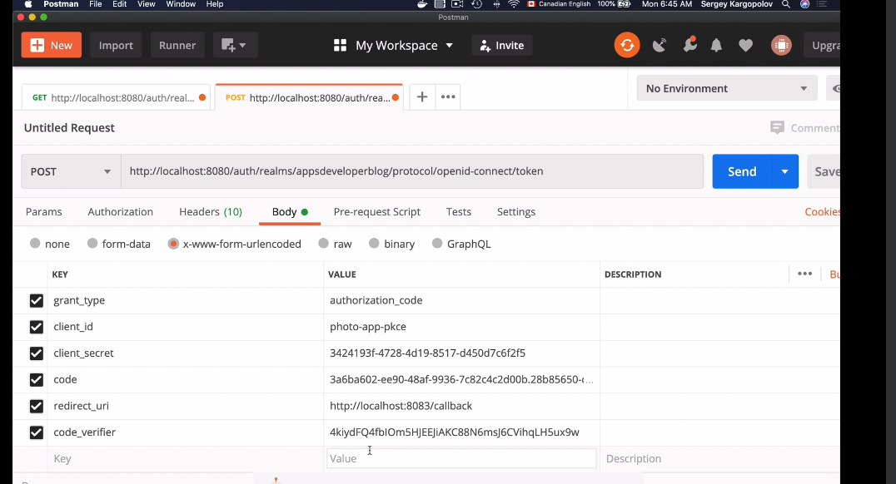

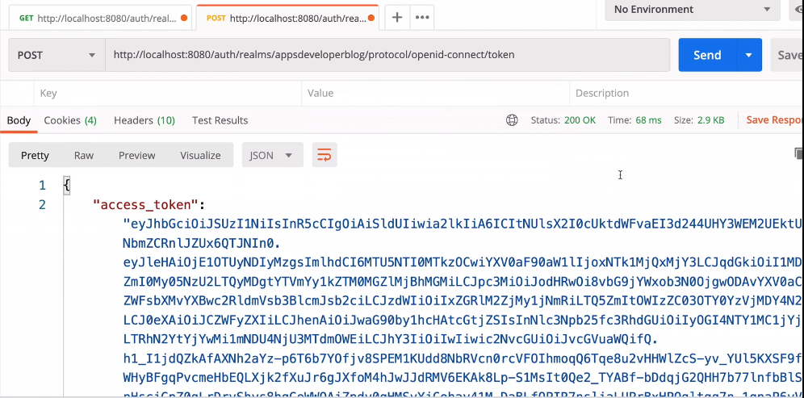

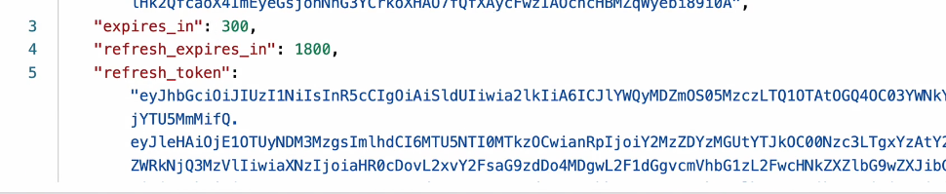

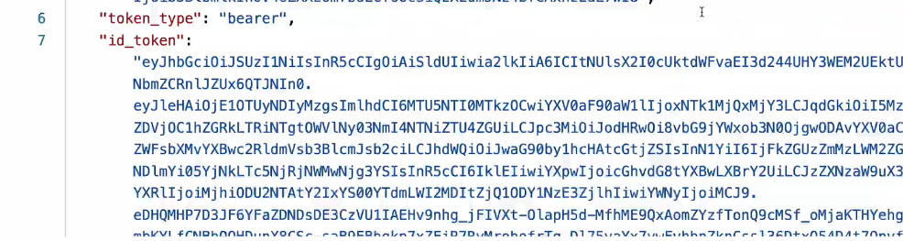

**Grant Type = Client Credentials (machine to machine – No user name/password, microservice & microservice communication)**

POST method call with ***client_id, client_secret, scope, grant_type=client_credentials***

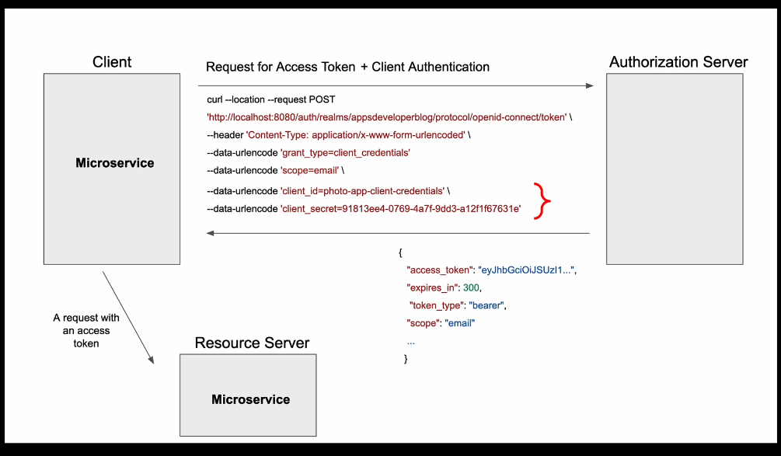

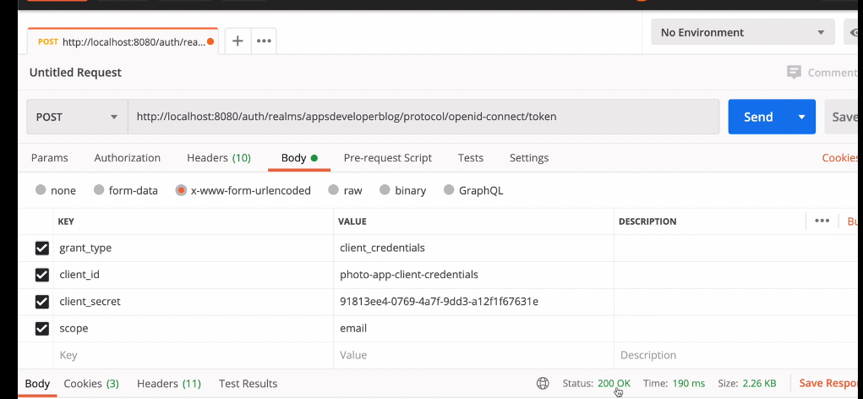

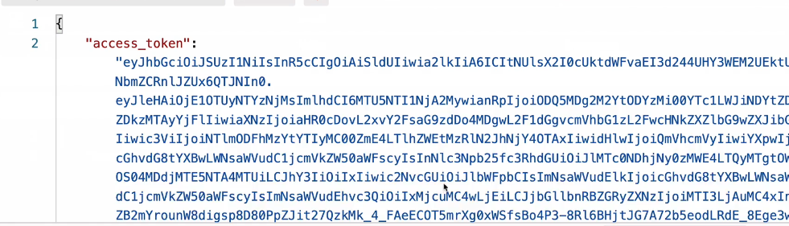

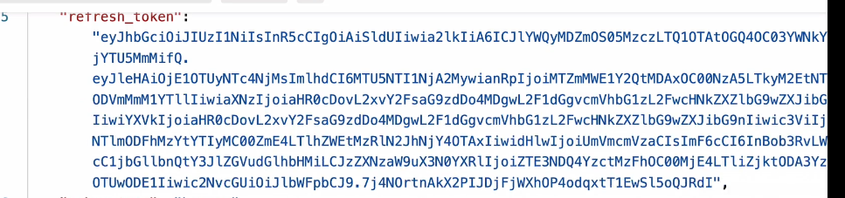

**Grant Type = Password Grant (if Application does not support redirect) – username/password**

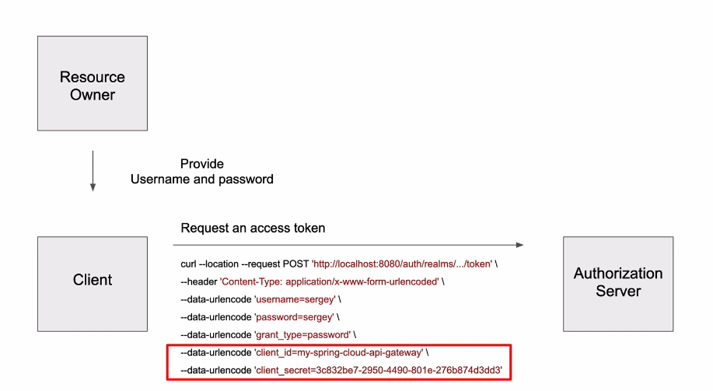

HTTP post method with username/password – auth server would have provided the username/password to the client and client would use it get the auth token

***Grant_type=password, username, password, client_id, client_secret, scope***(profile)

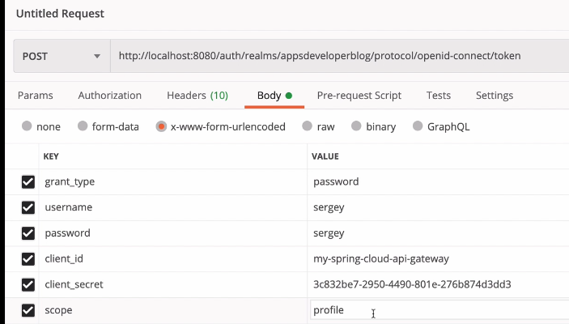

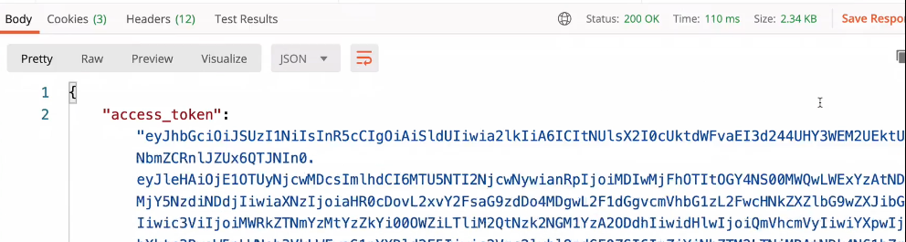

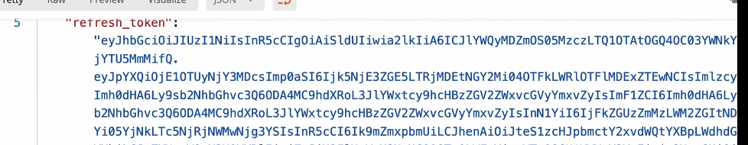

**Refreshing Access Token**

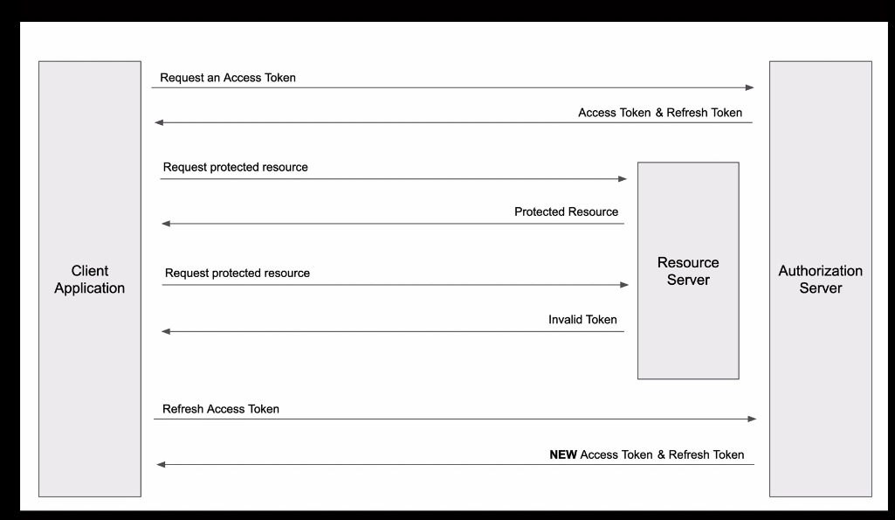

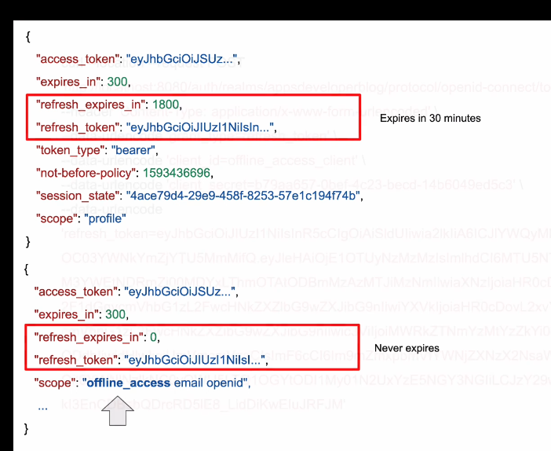

POST ***grant_type=refresh_token, client_id, client_secret***

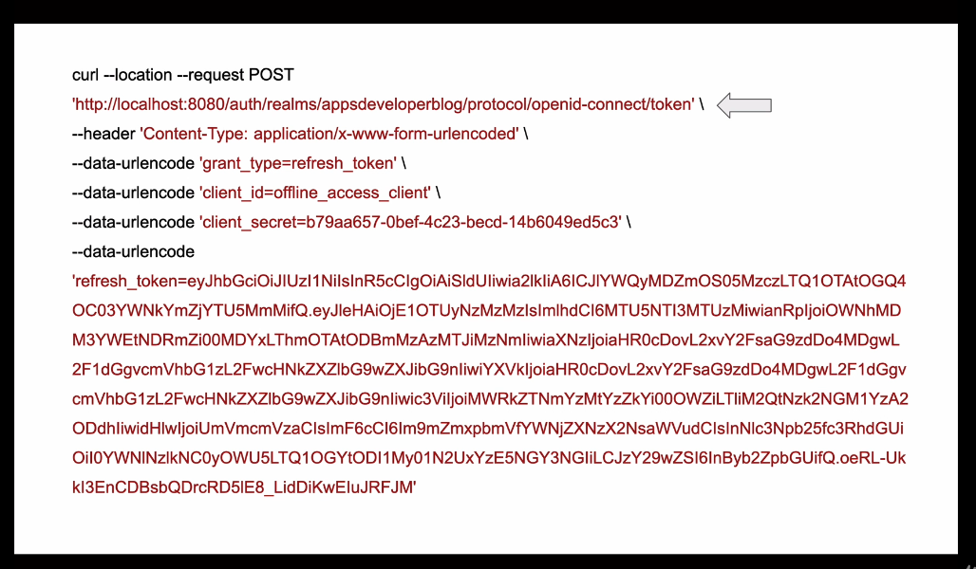

Refresh token never expires

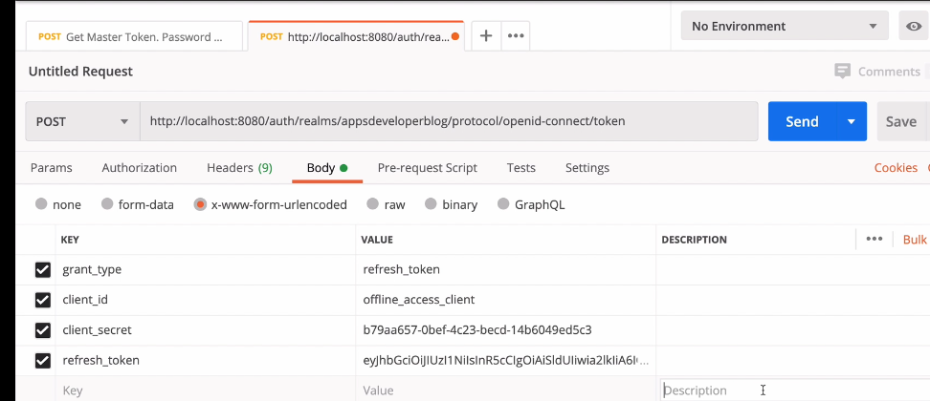

Keycloak – Evaulaue user tokens

